**CB[1] – Using Software Key**

**Type in your score here 🡪 ____ out of 25 points possible**

1. (5 points) Ponder/Reflect Exercise – Reflect on what you have learned from this portion of the class. Examples of what you can do are: a brief outline of material covered, insights you gained from class or personal study, or items you feel that you need to follow up or work on. (3-5 sentences)

**Any thoughtful answer is sufficient.**

2(a) Use the file marketing.txt from the homework page. The first column is sales of a product of interest (in dollars), the second column is the shelf height factor (shelf height for the product being sold), and the third column is day of week (the blocking factor). On each day, the researcher in this study randomly assigned a product of interest to a location on a five-level store shelf and then recorded the total sales for each shelf at the end of the day. Our primary interest is to see if the shelf heights have different mean sales. Use two of the following software: SAS or R to analyze the data and do the following:

1. (5 points) Check the assumption of equal variance and residuals being normally distributed using two software.

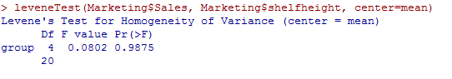

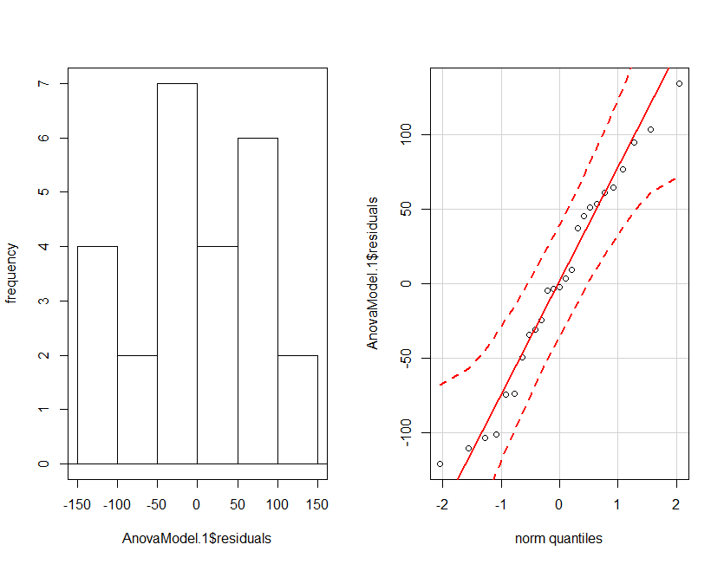

**The residuals appear to be normal and since we don’t reject the null on the levene’s test, we can assume that the variances are equal.**

1. (4 points) Get an ANOVA table using using two software

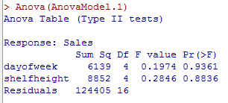

1. (5 points) For effect of interest: i) state the null and alternative hypotheses, ii) give the test statistic, iii) give the degrees of freedom, iv) state the p-value, v) determine whether you should reject or not reject the null hypothesis, and vi) write a sentence which gives an appropriate conclusion.

**Ho: µSH1= µ SH2= µSH3= µSH4= µSH5 Ha: at least one of the population means is different**

**Test Statistic F=0.285**

**Degrees of Freedom Num df=4 Den df=16**

**P-value = 0.884**

**Since the p-value is greater than 0.05, we would NOT reject the null hypothesis**

**Therefore, we have insufficient evidence that at least one of the population means is different**

1. (2 points) Does the blocking factor turn out to be an important source of variability?

**Compared to the residual error (looking at sum of squares), it appears that day of the week doesn’t appear to be an important source of variability.**

(b) (4 points) Now ignore the blocks and re-run the analysis as a BF[1] design using either R or SAS. What are the degrees of freedom for the F distribution used to test for shelf height? How do your conclusions change? Why are the results different from the CB[1] analysis?

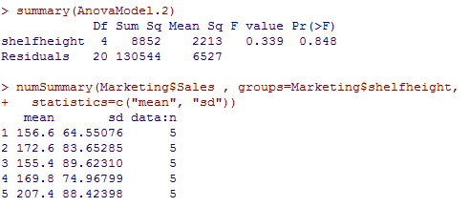

**Degrees of Freedom for the numerator is equal to 4 and the degree of freedom for the denominator is 20 (which is different than the 16 for part c).**

**Since the p-value is still quite high, there appears to be no effect in the shelf height.**